Lower Columbia River Fish Facility Design Review Work Group (FFDRWG)

USACE, Portland District

# November 2021 Meeting Notes

November 4, 2021 09:00-10:22

## Introductions

FFDRWG members:

*In attendance

**BPA**

Scott Bettin

Kim Johnson

Siena Lopez-Johnston

Christine Petersen

Greg Smith

Leah Sullivan

Ben Hausmann

**NOAA**

Blane Bellerud

Gabriel Brooks

Trevor Conder

Kinsey Frick

Claire McGrath

Josie Thompson

Logan Negherbon

**USFWS**

Dave Swank

**States**

Erick Van Dyke (ODFW)

Charles Morrill (WDFW)

Jonathan Ebel (IDFG)

**CRITFC/Tribes**

Tom Lorz (CRITFC)

Blaine Parker (CRITFC)

Tom Skiles (CRITFC)

Laurie Porter (CRITFC)

Greg Silver (CRITFC)

Casey Baldwin (CTCR)

Michael Karnosh (CTGR)

Lawrence Schwabe (CTGR)

Torey Wakeland (CTGR)

Aaron Jackson (CTUIR)

Ralph Lampman (YN)

**NPCC**

Leslie Bach

Kris Homel

**FPC**

Erin Cooper

**PSMFC**

Alan Brower

Darren Chase

Roger Clark

Mark Leonard

Scott Livingston

Nicole Tancreto

Don Warf

**CENWD**

Doug Baus

Tim Dykstra

Dan Feil

Mike Langeslay

Cindy Studebaker

Lisa Wright

**CENWW**

Karl Anderson

Chris Peery

Denise Griffith

**CENWP-OD**

Andrew Derugin

Rebecca Cates

Jeanette Wendler

Bob Cordie

Jeffrey Randall

Scott Fielding

Eric Grosvenor

Michael Lotspeich

Laura Ricketts

Tammy Mackey

Darren Gallion

Nathan McClain

Robert Wertheimer

Karrie Gibbons

**CENWP-PM**

Jim Adams

Eric Bluhm

Ian Chane

Jeff Hicks

Steve Sipe

Brad Eppard

David Griffith

Fenton Khan

Rachel Laird

Jake Macdonald

Rich Piaskowski

Jon Rerecich

Ida Royer

David Trachtenbarg

Jeremiah Woodard

Erin Kovalchuk

Michael Carl *welcome*

**CENWP-ENC**

Adam White

Brandt Bannister

Bridget Bell

Jonathon Brink-Roby

Shari Dunlop

Laurie Ebner

Curtis Lipski

Chris Motti

Steve Schlenker

Max Wilson-Fey

Mehdi Roshani

## Action items from previous meetings

* Derugin and Macdonald will distribute a collection of LPS design criteria/guidelines to the appropriate PDT’s and FFDRWG
  + Work in progress
* Grosvenor will present the backup AWS debris management alternatives at an upcoming FFDRWG
  + EDR shelved at 50% with no funding in FY 22. Grosvenor will walk through alternatives with FFDRWG at 60% (when the project resumes)
* BPA (Bettin) will present the TDA fish unit rehab report at an upcoming FFDRWG
  + Not this month

## Topics for FFDRWG Discussion/Review/Coordination

* JDA adult lamprey passage improvements – Eric Bluhm (PM), Adam White (TL), Eric Grosvenor (FC)
  + Update on gravity feed water supply alternatives investigation (Grosvenor/White)
    - Action: Macdonald will email 3-D PDF model of the John Day North fish ladder to FFDRWG.
    - Conder asked if the AWS drain screen would meet fry criteria. Grosvenor responded that there is about 30 cfs of upwelling water coming through ¾-inch lamprey friendly grating that would exclude fry or smolt from swimming down into it. Conder asked if it would be impossible for fry to enter the drain valve. Grosvenor responded it is very nearly impossible. He has worked at John Day for 12 years and has never had to clean that diffuser pit. It is self-cleaning due to amount of AWS flow. Conder said just get it screened to fry criteria and you’re good.
    - Morrill likes the concept, agrees Trevor’s concern about fry screening merits attention.
    - Negherbon asked for more detail on the hydraulic conditions in the diffuser chamber. Does the AWS flow have juveniles in it or is it already screened? What is the diffuser grating velocity? Have we confirmed diffuser grating velocity is uniformly positive (ie, potential for backflow or entrainment into the well)? How far from the grating is the drain inlet?
    - The current 3-D PDF model doesn’t have the features in it to answer those questions today.
    - Action: Grosvenor and White will find and distribute as-built drawings that detail the configuration of the diffuser chamber.
* BON2 adult lamprey passage improvements – Michael Carl (PM), Shari Dunlop (TL), Andrew Derugin (FC)
  + Site specific construction cost estimate is in! (Dunlop)
    - $5-7M for construction, includes engineering during construction but does not include pre-construction design costs.
  + Overview of current (<30%) design weirs and antennas (Dunlop/Brower)
    - Morrill asked about modeling this fish ladder at ERDC. Dunlop responded we were trying to avoid building a physical model due to high cost and delaying the schedule. Current plan is to model this design with a CFD model based on and calibrated to John Day North
    - *Conder reminded the team that all construction must be completed during the in-water work window. Dunlop is aware of the 2 ½ month window and the PDT are thinking about ways to decrease in-water work time like pre-casting some components. Completing this re-build during the in-water work window will be important for NOAA to support this project going forward.*
  + Chamfer or radius on orifice edges? (Dunlop/Brower)

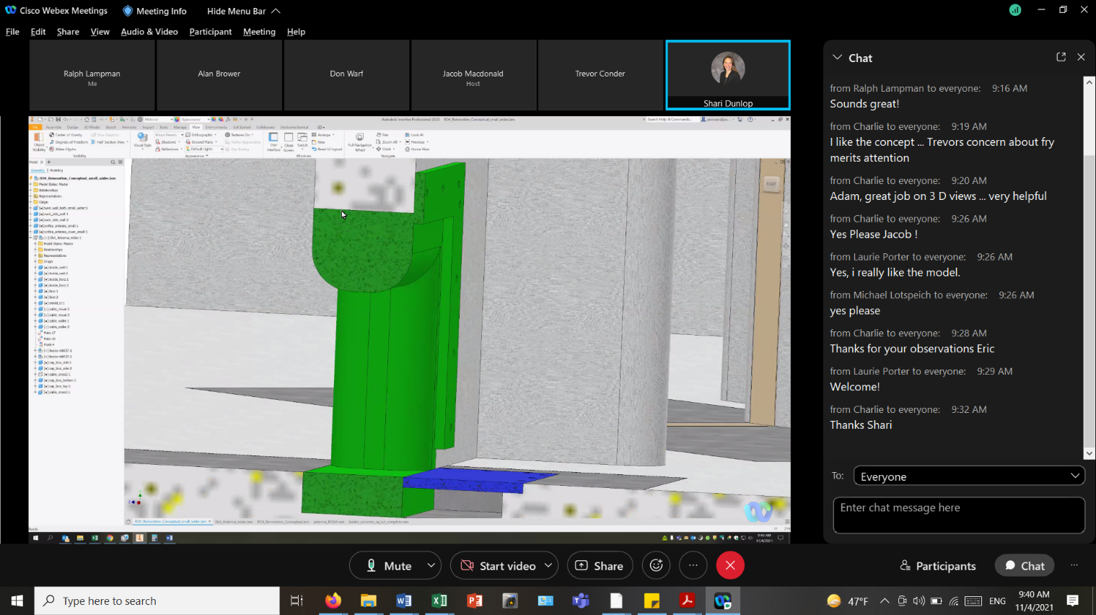  
Section view of a conceptual orifice antenna housing with radiused edges (screen capture from Alan Brower’s live demo). A chamfer design would simplify the curved profile with flat faces that are easier to build

* + - Frick said a radius is important for the sides but not so important for the top.
    - Warf commented we have orifice antennas from Bonneville to Lower Granite and none of them are rounded. It is very difficult to make rounded edges using plastic.
    - Lampman commented that the re-modeled River Mill Dam had chamfered several corners and it seems to work fine.
    - Lampman suggested making the salmon orifice flush with the right-hand wall (or close to the wall with a ramp). If we do that, maybe the left-hand side of the salmon orifice as well as top could be chamfered.
    - Lampman added a reminder to the PDT to ensure the floor and walls through the slots and orifices and antenna edges are completely smooth with no gaps or ridges (perspectives on what is smooth are different for the average person vs. the average lamprey). Even a small gap or ridge can cause lamprey to detach and fall back or hold in place causing long term detections and interferences.

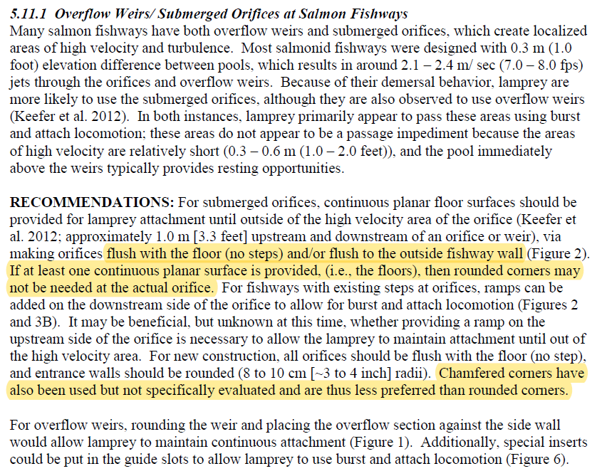

Excerpt from page 19 of: Pacific Lamprey Technical Workgroup. 2017. Practical guidelines for incorporating adult Pacific lamprey passage at fishways. June 2017. White Paper. 47 pp + Appendix. Available online: https://www.fws.gov/pacificlamprey/mainpage.cfm

* + PIT detectors for lamprey orifices? (Dunlop/Brower)
    - If there are lamprey orifices in the weirs where the PIT antennas are installed, they should have antennas.
    - Lampman suggested building lamprey orifices on the left side that are flush with the left wall in all weirs & add a PIT array on at least the upper and lower most ones (or all 4)
    - McClain questioned the need for lamprey orifices at all. Lamprey orifices have been used in serpentine sections where there are no other orifices. This design is different in that it has floor level salmon orifices that will be designed with lamprey passage in mind.
  + Orifice configuration
    - Macdonald asked about the possibility of two salmon-size orifices in each weir. Dunlop responded it’s something the PDT could look at in the model but probably would not work because slot widths would have to be too narrow to compensate for the increased orifice flow. Schlenker added that crossing jets from the angled slot and normal orifice would create hydraulic chaos in the pools.
    - Macdonald asked about moving the orifices flush with the wall to give lamprey two continuous planar surfaces (the floor and the wall).
    - Schlenker responded we have looked at that before and it didn’t work, citing the JDA North Exit Section & Count Sta DDR (PDF pages 50-51) which says:

*“The lamprey-improved weirs showed promise but needed refinements. Most particularly, the orifice location would need to be moved from the sidewall back four feet inward to the original location used in the JDAS configuration. Flow through the sidewall orifice was very fast with little jet dissipation between pools. Based on the sight of unaltered dye traces streaking down several pools, there was a concern that energy through the orifices could be accumulating in the downstream direction. The biologists also reasoned that the fish approach the orifice from both sides in the hydraulic shelter behind the wall, and a high velocity trained along the sidewall would actually restrict access from that side. While the sidewall orifices were attempted on behalf of the lamprey, it was also deemed that lamprey would fare better in the original JDAS locations, since they also would approach from both sides. The edges of the orifices would remain rounded to improve lamprey access.”*

* + - Schlenker added that he recently reviewed a fish passage system for the Sacramento District, and the A/E designer on that project tried the same thing. Their CFD results show the same thing that we saw in the John Day physical model: excessively high velocities with insufficient dissipation or slow down between orifices.
    - Lampman suggested a staggered configuration where half the orifices are flush with the wall and half are offset from the wall. Another thing the PDT can look at in the model when they get to that point.
* BON1 adult lamprey passage improvements – Michael Carl (PM), Adam White (TL), Andrew Derugin (FC)
  + Lamprey orifices going in the serpentine section this Winter (Derugin)
    - A full row of 1-1/2 inch high orifices on the viewing window side of the serpentine section with refuge boxes distributed between to provide a straight-line path for lamprey from the count station exit to the fishway exit slot.
  + FFDRWG site visit to the dewatered ladder in December-January? (Macdonald)
    - All visitors who want to enter the fishway will need to complete an online safety training covering the Corps’ hazardous energy control program (HECP)
    - Action: Macdonald will send out a doodle poll for interested FFDRWG members to visit the Bradford Island fishway in early to mid January and help coordinate safety training for those who need it.
* Ladder cooling water - **\*\*potential future project\*\***
  + Continue discussion of the feasibility of a ladder temperature control project at John Day Dam, transition discussion to AFEP/SRWG or FPOM (Grosvenor/Macdonald/Conder)
    - Conder asked if the Corps is ready to commit to a temperature control project at JDA
    - The Corps does not have funding in FY 2022 to commit to any new work but we do remember NOAA’s 2020 BiOp recommendation to look in to it. The best we can do right now is commit to help NOAA keep the topic alive in SRWG and FPOM and considered whenever there is funding to put toward it.

## Written project updates

* JDA turbine rehab – Steve Sipe (PM), Curtis Lipski (TL), Jon Rerecich (FC)
* TDA AWS Debris Management– Erin Kovalchuk (PM), Mehdi Roshani (TL), Eric Grosvenor (FC)
* BON Second Powerhouse FGE – Jim Adams (PM), Bridget Bell (TL), Eric Grosvenor (FC)
* JDA adult lamprey passage improvements – Eric Bluhm (PM), Adam White (TL), Eric Grosvenor (FC)
* TDA adult lamprey passage improvements – Eric Bluhm (PM), Adam White (TL), Eric Grosvenor (FC)
* BON1 adult lamprey passage improvements – Michael Carl (PM), Adam White (TL), Andrew Derugin (FC)
* BON2 adult lamprey passage improvements – Michael Carl (PM), Shari Dunlop (TL), Andrew Derugin (FC)

## Next meeting scheduled for December 2nd at 09:00

Fish Facility Design Review Work Group (FFDRWG)

USACE, Portland District

Project Update

Date Prepared/Updated: 2021-04-01

# JDA Turbine Rehab

|  |  |
| --- | --- |
| Project Identifier: | P2 # |
| Project Manager (PM): | Steve Sipe (CENWP-PMF-P)  *Steven.C.Sipe@usace.army.mil* |
| Technical Lead (TL): | Curtis Lipski (CENWP-ENC-HD)  *Curtis.L.Lipski@usace.army.mil* |
| FFDRWG Coordination (FL): | Eric Grosvenor (CENWP-PME)  *Eric.Grosvenor@usace.army.mil* |

## Project Description

The purpose of this project is to address reliability concerns and maximize production of hydroelectric power at JDA, which includes electrical energy production and electrical grid ancillary services while at the same time, improving survival of fish passing through the turbines. Maximum production of hydroelectric power at JDA will be realized through increased reliability and increased efficiency. Reliability improvements will be realized through a combination of replacement and refurbishment of powertrain equipment to include, but not limited to, turbine runners, shafting, generators, isophase bus, breakers, switches, and transformers. Efficiency improvements will be realized through increased turbine efficiencies associated with new turbine runners and other modifications to the turbines.

The purpose of this project is also to increase survival of turbine passed fish. Increased survival of turbine passed fish will be realized through developing state-of-art hydroelectric turbines to obtain improved fish passage survival through the turbines. The design of the state-of-the-art turbines will be an iterative and collaborative process that focuses on fish-friendly design features and criteria. This iterative and collaborative design process will be similar to the ongoing Ice Harbor L&D turbine runner replacement design and upcoming McNary L&D turbine runner replacement in NWW. Phase 1A recommendations include replacing up to 14 units with combination fixed blade & adjustable blade to obtain improved fish passage survival through the turbines.

## Project Schedule

|  |  |  |
| --- | --- | --- |
| Phase 1 Short Term Schedule | Start | Finish |
| 30% DDR/P&S review | 3/12/2020 | 4/1/2020 |
| 60% DDR/P&S review | 8/28/2020 | 9/18/2020 |
| 90% DDR/P&S review | 9/21/2021 | 2/18/2022 |
| BCOES review | 1/24/2022 | 11/11/2022 |

|  |  |
| --- | --- |
| Overall Schedule Milestones | Date |
| Contract award | October 2024 |
| Collaborative design process Model testing | 2024-2029 |
| First unit installation | 2031-2033 |
| Unit installation complete | 2040-2045 |

## Current Status

* Final VE study report due Feb. 19, 2021
* The 1:25 scale physical observational turbine model rehab and relocation is complete. The model will be used to inform the development of the Phase 1 Plans and Specifications package, to document the hydraulic conditions that affect the biological performance of the existing JDA turbines, and to support the collaborative and iterative design process in Phase 2. ERDC baseline model validation testing with the existing runner has been scheduled for last week and this week. Baseline model data collection for Test Series 1 will be occurring until May 2021 at which time ERDC is scheduled to transition back to McNary. This task includes preparation of a data report documenting the runs performed, results, conclusions, and recommendations. Runner evaluation tests will need to carry over to Test Series 2 (not yet scoped), which is expected to occur in late 2021 or early 2022.
* Tailrace flow patterns have been validated in the 1:45 JDA general model and in a CFD model. Model runs will commence after further HAC modeling is complete and preliminary options for the turbine mix are established. The focus of the tailrace modeling will be to assess juvenile egress and conditions for adult approach to the fish ladder entrances.

## Topics for FFDRWG Review/Coordination

None currently.

Fish Facility Design Review Work Group (FFDRWG)

USACE, Portland District

Project Update

Date Prepared/Updated: 2021-10-28

# TDA Backup AWS Debris Management EDR

|  |  |
| --- | --- |
| Project Identifier: | P2 # |
| Project Manager (PM): | Erin Kovalchuk (CENWP-PMF)  *Erin.H.Kkovalchuk@usace.army.mil* |
| Technical Lead (TL): | Mehdi Roshani (CENWP-ENC)  *Mehdi.Roshani@usace.army.mil* |
| FFDRWG Coordination (FC): | Eric Grosvenor (CENWP-PME)  *Eric.Grosvenor@usace.army.mil* |

## Project Description

This project is to evaluate alternatives to remove debris from The Dalles Dam Auxiliary Water Supply (AWS) trash rack. Debris build-up on the rack currently causes high head differential across the rack. Fish Unit Rehab requires the AWS backup system to operate during the rehab to provide adequate flow for fish attraction. Fish Unit Rehab duration is one year per unit for a total of two years. Long term use of the backup AWS system will be part of the alternatives evaluation.

## Project Schedule

|  |  |  |
| --- | --- | --- |
| **Milestone** | **Start** | **End** |
| **Criteria and Constraint Report** | 4/19/2021 | 8/6/2021 |
| **Value Management** | 8/9/2021 | 8/20/2021 |
| **Alternative Evaluation Report** | 8/23/2021 | 12/10/2021 |
| **Draft Final Report** | 12/13/2021 | 4/1/2022 |
| **ATR** | 3/21/2022 | 4/1/2022 |
| **Final Report** | 4/4/2022 | 5/27/2022 |
| **Closeout** | 5/30/2022 | 6/3/2022 |

## Current Status

Value Management Study completed.

No Funding in FY 22

Engineering Design Report (EDR) shelved at 50%

## Topics for FFDRWG Review/Coordination

PDT will solicit FFDRWG participation at the 60% Engineering Design Report (EDR).

Fish Facility Design Review Work Group (FFDRWG)

USACE, Portland District

Project Update

Date Prepared/Updated: 2021-10-28

# BON Second Powerhouse FGE

|  |  |
| --- | --- |
| Project Identifier: | P2 # |
| Project Manager (PM): | Jim Adams (CENWP-PMF)  *James.R.Adams@usace.army.mil* |
| Technical Lead (TL): | Bridget Bell (CENWP-ENC)  *Bridget.M.Bell@usace.army.mil* |
| FFDRWG Coordination (FL): | Eric Grosvenor (CENWP-PME)  *Eric.Grosvenor@usace.army.mil* |

## Project Description

Steel plates were installed in all units in the A and B gatewells to restrict flow. During routine inspections, however, it became apparent that the anchoring system for the steel plates was inadequate. In effect, the nuts and anchoring bolts holding down the plates had come loose, posing the risk that the plates could detach and potentially take out a unit. All flow restriction plates were removed from the units. A concrete corbel will be installed in the same location as the flow control plates with the design goal to achieve similar gatewell hydraulic conditions as the flow control plates. This new concrete corbel has been designed to meet the flow criteria established and tested for the previous flow restrictor plates to meet the hydraulic and biological goals.

## Project Schedule

|  |  |  |  |  |
| --- | --- | --- | --- | --- |
| CLIN | Status | Description | Award/Exercise Date | Construction Execution Window |
| 1 | Mandatory | Mobilization/Demobilization | Awarded December 2020 | Complete |
| 2 | Mandatory | Unit 15 Construction | Awarded December 2020 | Complete |
| 3 | Optional | Second Mob/Demob and Unit 11 Construction | Awarded August 2021 | Dec 2022-Feb 2023 |
| 4 | Optional | 2 Additional Units | Awarded August 2021 | Extend through May 2023 |
| 5 | Optional | 2 Additional Units | Awarded August 2021 | Extend through August 2023 |
| 6 | Optional | 2 Additional Units (Unit 18 + 1 more Unit) | Awarded August 2021 | Extend through February 2024 |

## Current Status

* Construction in unit 15 is complete. The contractor did great work, and we had very few RFIs and only one modification.
* Optional construction CLINs were awarded August 2021. We will modify the dates of execution extending them out a year to allow us to test in the spring of 2022 prior to installing the remaining corbels.
* AE contract for hydraulic testing in Spring 2022 was awarded in September 2021. Hydraulic tests will be needed in the spring to meet the upper 1% test range of 18.0-18.5 kcfs.
* Original contract schedule said we would continue with units, 12, 13, 14, 16, and 17 and then end with either 11 or 18 the following IWW. However, the contractor thinks they can do both 11 and 18 in the 2022-2023 IWW and then finish with the remaining units throughout the spring/summer. The PDT is confident they can achieve that after how well unit 15 went. We will confirm their schedule after we get the modification in place.
* Rerecich owes Lorz a beer.

## Topics for FFDRWG Review/Coordination

None currently.

Fish Facility Design Review Work Group (FFDRWG)

USACE, Portland District

Project Update

Date Prepared/Updated: 2021-10-27

# JDA adult lamprey passage improvements

|  |  |
| --- | --- |
| Project Identifier: | P2 # 492402 |
| Project Manager (PM): | Eric Bluhm (CENWP-PM-FP)  *Eric.V.Bluhm@usace.army.mil* |
| Technical Lead (TL): | Adam White (CENWP-ENC)  *Adam.J.White@usace.army.mil* |
| FFDRWG Coordination (FC): | Eric Grosvenor (CENWP-PME)  *Eric.Grosvenor@usace.army.mil* |

## Project Description

### Modify NFL LPS to increase the capacity and reliability of the system

This is a fish safety/health issue, and the upgrade needs to happen. Current water supply is insufficient so tank cannot be installed without upgraded water supply. SeeJanuary 2020 CRS BA § 2.5, pg. 2-85***.***

1. gravity-fed water supply or alternative, more reliable pump configuration.
2. larger collection box

### SFL entrance improvements (rounded crest, slot cover/filler)

Caps may not be able to be added to South Ladder entrance weir due to FPP submergence criteria, so the weir may need to be modified more extensively to provide rounded weir crests and guide slot covers.

### SFL count station collection and counting structure (trap) improvements

*Increase capacity and efficiency of system with a larger opening into box; larger box, modified guide, and removal of gate and counting-related structure.*

## Project Schedule

Design: FY 2021 – FY 2022

30% DDR – July 2021

60% DDR – November 2021

90% DDR – April 2022

BCOES – May 2022

Construction: December 2022 - March 2023

Evaluation/Closeout: FY 2023

## Current Status

60% DDR is underway. PDT is evaluating options for gravity feed water from behind existing picketed leads near the count station via an existing diffuser drain line. A surplus holding tank at JDA will be modified and relocated to serve as the larger collection box.

## Topics for FFDRWG Review/Coordination

None currently. PDT will ask for FFDRWG review of design alternatives at 60% or 90% DDR stage.

Fish Facility Design Review Work Group (FFDRWG)

USACE, Portland District

Project Update

Date Prepared/Updated: 2021-10-27

# TDA adult lamprey passage improvements

|  |  |
| --- | --- |
| Project Identifier: | P2 # 492403 |
| Project Manager (PM): | Eric Bluhm (CENWP-PM-FP)  *Eric.V.Bluhm@usace.army.mil* |
| Technical Lead (TL): | Adam White (CENWP-ENC)  *Adam.J.White@usace.army.mil* |
| FFDRWG Coordination (FC): | Eric Grosvenor (CENWP-PME)  *Eric.Grosvenor@usace.army.mil* |

## Project Description

### Lamprey collection system (LPS) at the east fish ladder junction pool

Provide a ramp (or multiple) for lamprey to swim out of the junction pool and into a collection box located below the upper segment of the fish ladder for upstream transport. SeeJanuary 2020 CRS BA § 2.5, pg. 2-85***.***

### Modify elevated orifices in EFL exit weirs 154-157

Provide better lamprey passage options through the 4 control weirs at the upstream end of the east fish ladder.

### Bulkhead slot covers

Design and install bulkhead slot covers at all four fishway entrances.

## Project Schedule

Design: FY 2021 – FY 2022

30% DDR – August 2021

60% DDR – December 2021

90% DDR – April 2022

BCOES – June 2022

Construction: December 2022 - March 2023

Evaluation/Closeout: FY 2023

## Current Status

60% DDR is underway. Preferred LPS design includes water supplied from an existing 6” pipe through the dam that provides irrigation water from the forebay to a park in the tailrace, a large collection box on the deck near the junction pool, and 1-3 climbing ramps reaching down to the fishway floor.

## Topics for FFDRWG Review/Coordination

None currently. PDT will ask for FFDRWG review of design alternatives at 60% or 90% DDR stage.

Fish Facility Design Review Work Group (FFDRWG)

USACE, Portland District

Project Update

Date Prepared/Updated: 2021-10-27

# BON1 adult lamprey passage improvements

|  |  |
| --- | --- |
| Project Identifier: | P2 # 492400 |
| Project Manager (PM): | Bob Winters (CENWP-PM-FP)  *Robert.Winters@usace.army.mil* |
| Technical Lead (TL): | Adam White (CENWP-ENC)  *Adam.J.White@usace.army.mil* |
| FFDRWG Coordination (FC): | Jacob Macdonald (CENWP-PME)  *Jacob.Macdonald@usace.army.mil* |

## Project Description

The project scope is divided into three parts:

### Entrance Modifications

Modify the B-branch fish ladder entrance to improve lamprey passage. This includes a variable-width entrance weir with rounded edges, guide slot fillers or covers to aid lamprey passage along the walls, and bollards on the channel floor for hydraulic refuge.

### Lamprey Collection

Provide an alternate route for lamprey entering the B-branch of the Bradford Island fish ladder. Fish would climb up a flume structure to a holding tank on the deck of the dam and be transported upstream by Tribal fisheries personnel. This will be designed so that in the future we could extend the system to provide volitional passage to the Bonneville forebay.

### Serpentine Section Extensive Minor Mods

Upgrade the serpentine section of the Bradford Island fish ladder to improve lamprey passage by rounding corners, providing refuge boxes, and lamprey orifices.

## Project Schedule

Design: FY 2021 – FY 2022

30% DDR – July 2021

60% DDR – October 2021

90% DDR – January 2022

BCOES – March 2022

Construction: December 2022 - March 2023

Evaluation/Closeout: FY 2023

## Current Status

60% DDR is underway. PDT is investigating alternatives for collection box location and gravity-fed water supply.

## Topics for FFDRWG Review/Coordination

None currently. PDT will ask for FFDRWG review of design alternatives at 60% or 90% DDR stage.

Fish Facility Design Review Work Group (FFDRWG)

USACE, Portland District

Project Update

Date Prepared/Updated: 2021-08-31

# BON2 adult lamprey passage improvements

|  |  |
| --- | --- |
| Project Identifier: | P2 # 492401 |
| Project Manager (PM): | Bob Winters (CENWP-PM-FP)  *Robert.Winters@usace.army.mil* |
| Technical Lead (TL): | Shari Dunlop (CENWP-ENC)  *Shari.L.Dunlop@usace.army.mil* |
| FFDRWG Coordination (FC): | Jacob Macdonald (CENWP-PME)  *Jacob.Macdonald@usace.army.mil* |

## Project Description

Full redesign of control section (DDR, P&S, Construction).

2020 CRS BA Chapter 2: Proposed Action (pg.2-85): “This measure would modify the serpentine-style flow control sections of Bonneville Dam’s Washington Shore and Bradford Island fish ladders, converting them to Ice Harbor-style vertical slot with submerged orifices configurations. This would improve passage conditions for adult lamprey and likely reduce stress and delay for adult salmon, steelhead, and bull trout. All full-duplex passive integrated transponder (PIT) arrays currently located in the control sections of these ladders would be replaced in kind or improved to maintain or enhance current levels of detection of PIT-tagged anadromous fish.

## Project Schedule

Design: FY2021-FY2024

Construction: Winter 2024/2025

Evaluation/Follow-on: FY2025-FY2026

Closeout: FY 2027

Preliminary Milestones:

* Project Kick-Off: ~ August 2021 (FY21 Q4)
* 30% DDR: ~ December 2021 (FY22 Q1) **\*FFDRWG review ~Jan 2022**
* 60% DDR: ~ April 2022 (FY22 Q3) **\*FFDRWG review ~May 2022**
* 90% DDR: ~ July 2022 (FY22 Q4) **\*FFDRWG review ~Aug 2022**
* Draft-Final: ~ September 2022 (FY23 Q1) **\*FFDRWG review ~Oct 2022**
* [Start P&S after 90% DDR DQC is complete, ~August 2022]

## Current Status

Ongoing preliminary hydraulic work leading to a site-specific cost estimate ~October 2021.

## Topics for FFDRWG Review/Coordination

None currently. PDT will ask for FFDRWG review of design alternatives at 30% DDR stage.

